人抬化轻便钻机配套动力头的技术特点对照说明
The Comparative Explanation of Technical Characteristics of Several Matching Power swivels
参考照片  Reference photo | 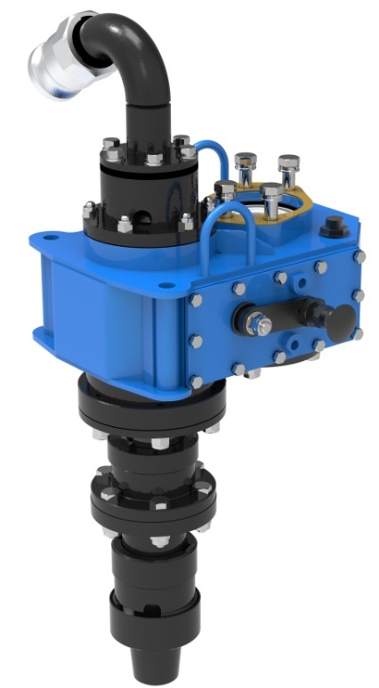 | 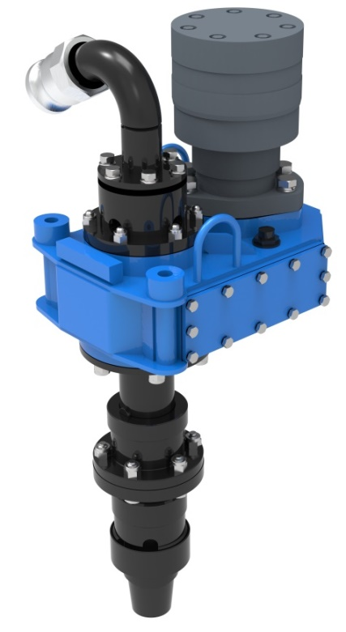 | 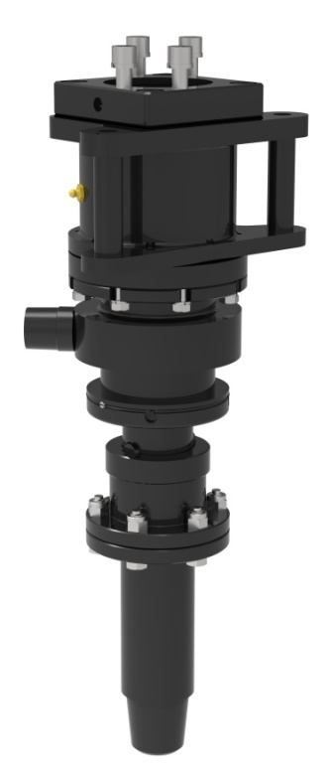 | 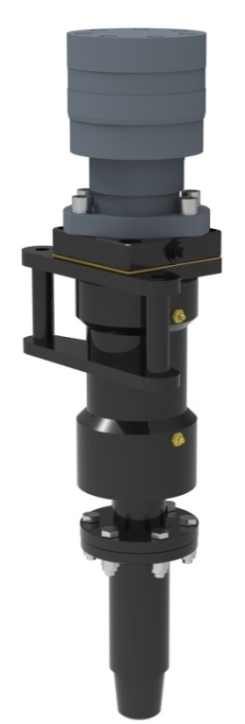
适用钻井方法  Applicable drilling methods | 泥浆/空气/螺旋钻井Mud scraping drilling  Air scraping/DTH Hammer drilling  Auger drilling | 泥浆/空气/螺旋钻井Mud scraping drilling  Air scraping/DTH Hammer drilling  Auger drilling | 泥浆/空气/螺旋钻井Mud scraping drilling  Air scraping/DTH Hammer drilling  Auger drilling | 空气/螺旋钻井  Air scraping/DTH Hammer drilling  Auger drilling
输出扭矩  Output torque (N.m) | 780/380 | 1100 | 1200 | 1200
输出转速  Output speed (r/min) | 0-140/300 | 0-220 | 0-160 | 0-160
外形尺寸  Overall dimensions (mm) | 313×299×622 | 283×260×625 | 191×210×497 | 191×210×491
重量(含马达等)  Rig weight (kg) | 46.5 | 40.9 | 41.5 | 32.5
安装厚度  Mounting Thickness(mm) | 94 | 94 | 100 | 100
安装孔距  Mounting hole distance(mm) | 170
齿轮机械变速  Gear speed change | 是/双速  Yes /Dual speed | 是/单速  Yes/ Single speed | 否No | 否No
导气/导水结构Air-conducting/water-conducting structure | 顶部轴向Top axial | 顶部轴向Top axial | 底部径向Bottom radial | 中部径向Middle radial
自动补偿式密封圈Automatic compensating sealing ring | 是Yes | 是Yes | 否/手动调整  No/ Manual adjustment | 否/不可调整  No/ Unadjustable
轴承/齿轮润滑方式Lubrication methods | 润滑油Oil | 润滑油Oil | 润滑脂Grease | 润滑脂Grease
液压马达互换性Interchangeability of hydraulic motors | 完全互换  Completely interchangeable | 完全互换  Completely interchangeable | 完全互换  Completely interchangeable | 完全互换  Completely interchangeable
下接头互换性Interchangeability of the lower adapter | 完全互换  Completely interchangeable | 完全互换  Completely interchangeable | 完全互换  Completely interchangeable | 完全互换  Completely interchangeable

